




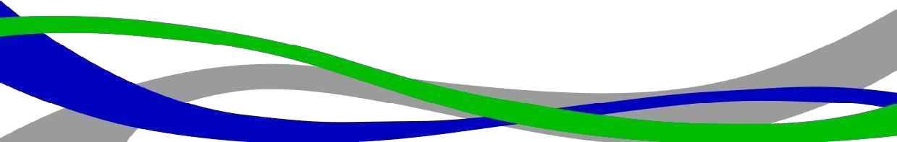

Ficha Técnica:

YONUSA K156L - Kit of 5 black 3/4" profile posts, 1.2 meters long, featuring 6 line-post insulators for 6 lines with 15 cm spacing. Ready for field installation.
Specification | Description
Post Profile | 3/4" Steel tube
Post Height | 1.20 meters
Insulators | 6 line-post (stand-off) insulators
Line Capacity | Supports up to 6 lines with 15 cm spacing between them
Color | Black
Kit Contents | 5 posts with 6 insulators each
Installation | Ready for field installation

